Health Advice Group

Table of Contents
Interface Design 3
Sitemap 3
Mock-ups 3
Homepage 3
Articles 4
Weather 4
Accounts 5
Cookies Policy 5
Terms and Conditions 6
About 6
Data Requirements 7
Data Dictionary 7
Entity-relationship Diagram 8
Algorithms 9
Test Strategy 10

Interface Design
This should have:
- Sitemap
- Well-annotated wireframes
- Mock-up for each page (justify design layout, colour schemes, text sizes and fonts)

Sitemap
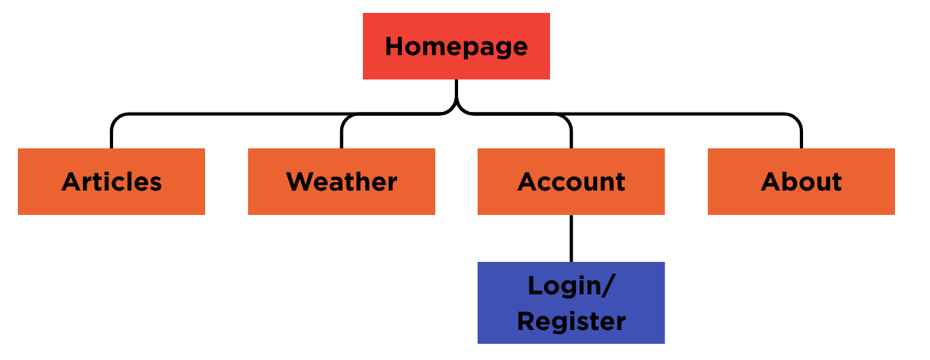

Mock-ups

Homepage
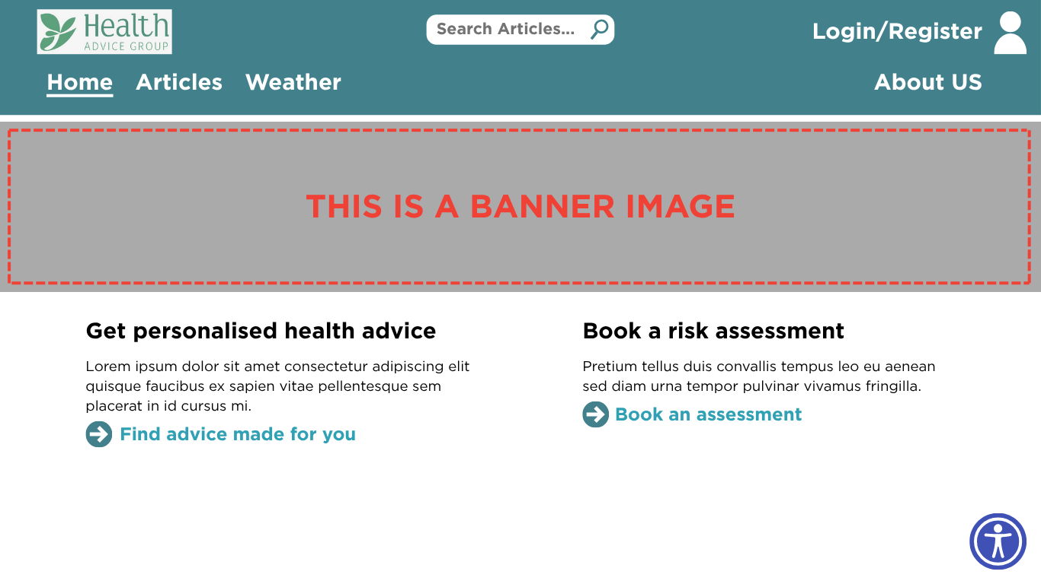

Articles
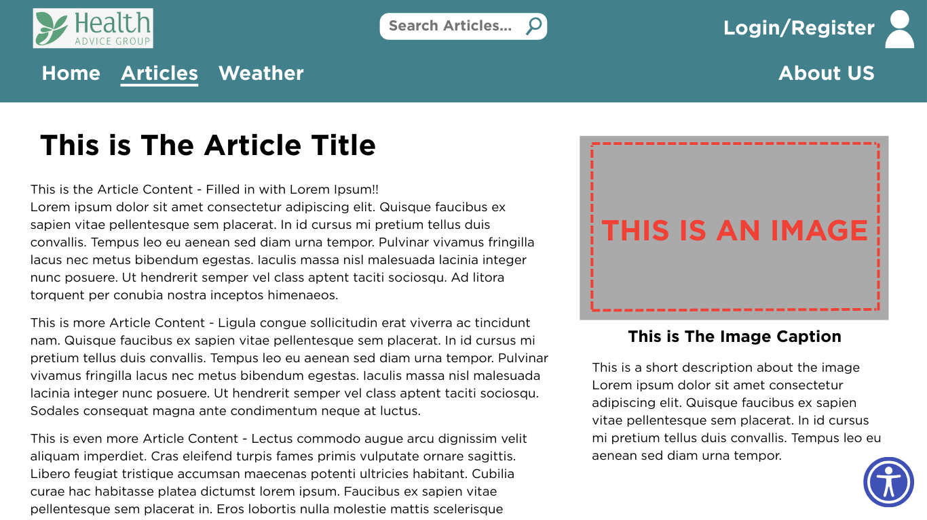

Weather
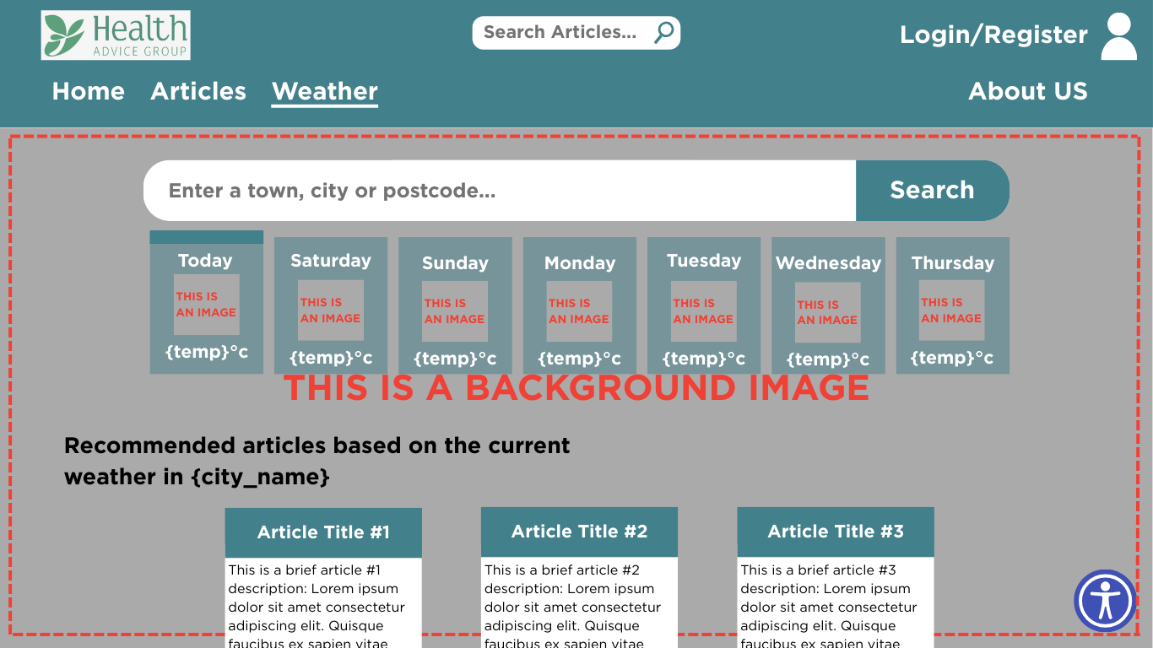

Accounts
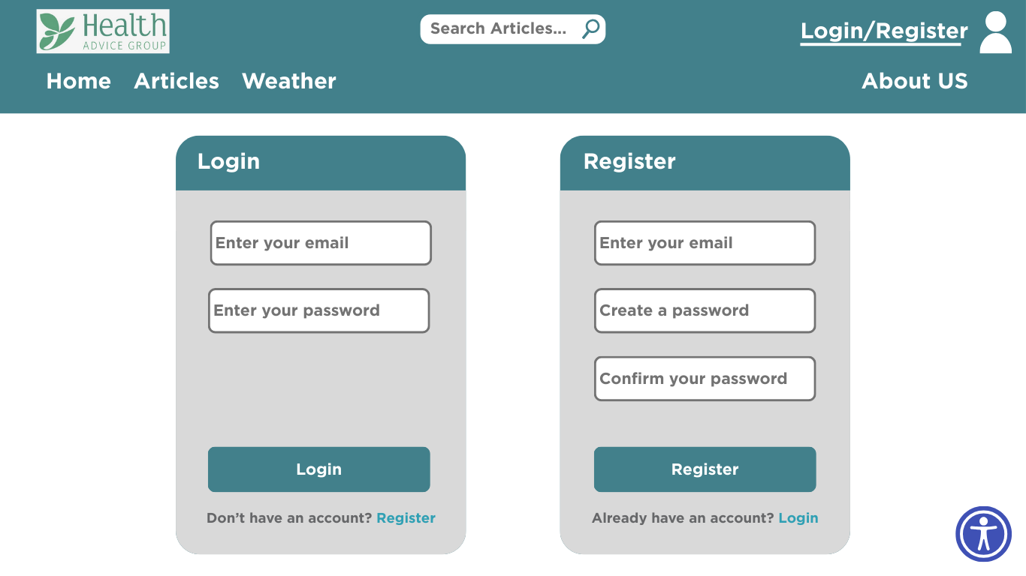

Cookies Policy
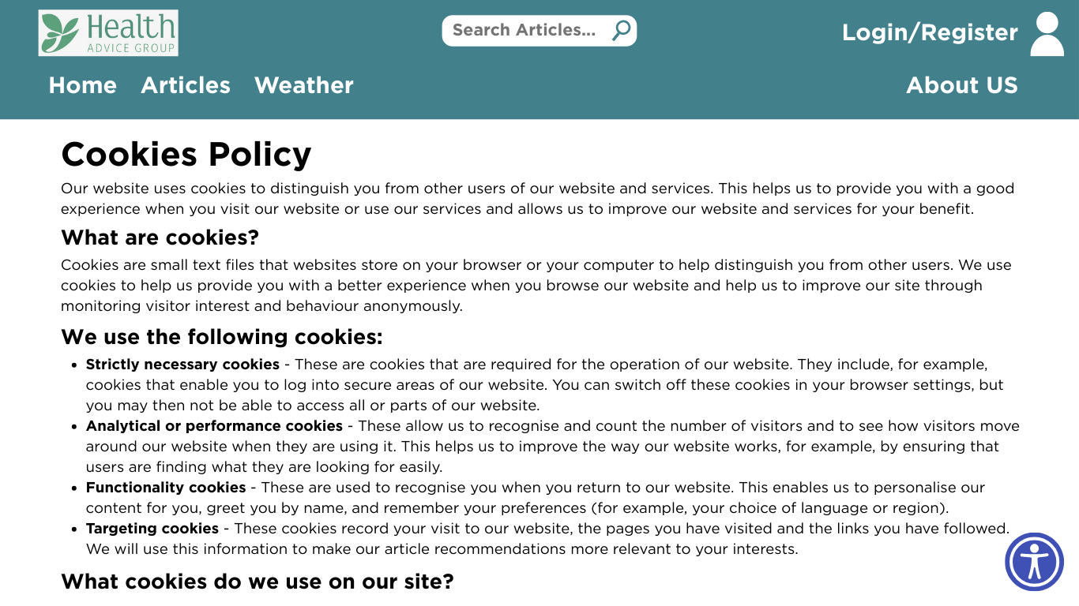

Terms and Conditions
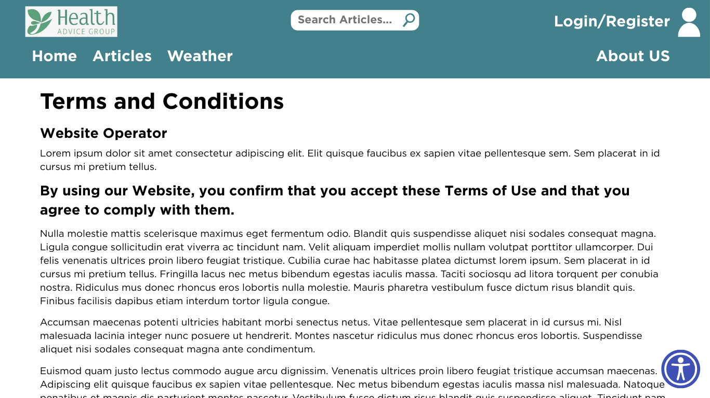

About
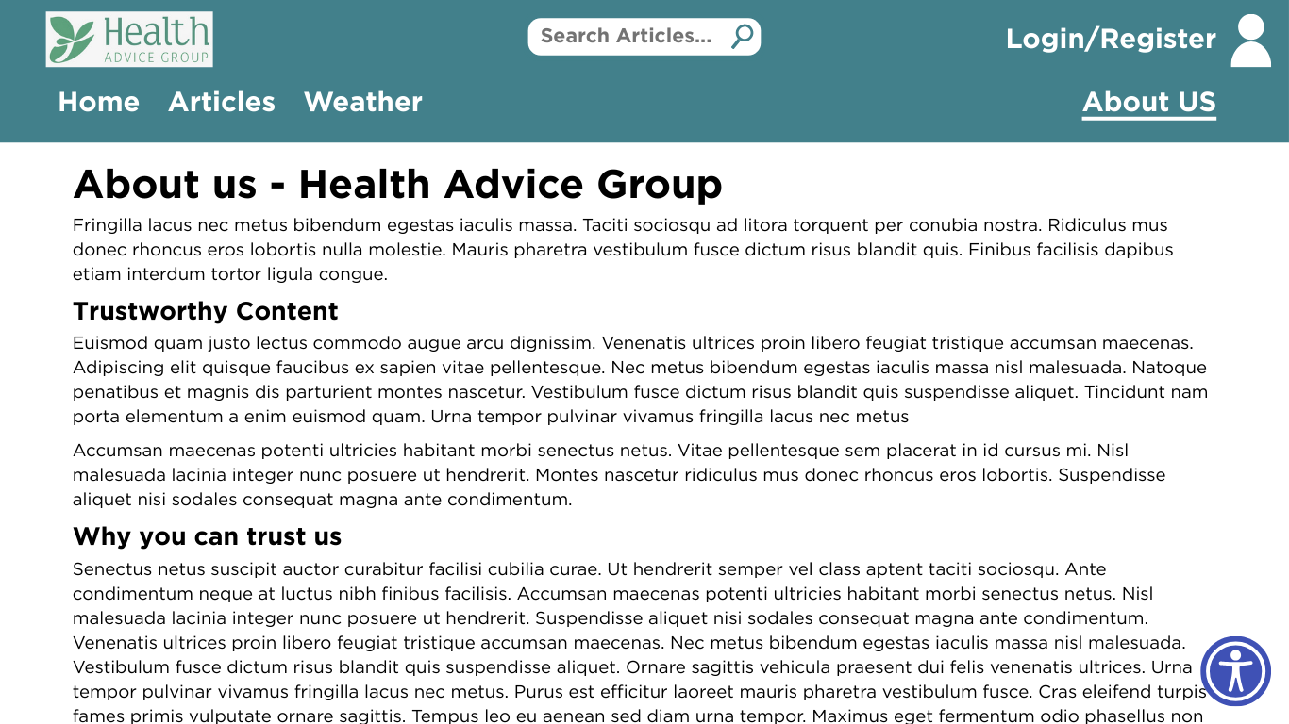

Data Requirements
This should have:
- Data dictionaries (variable names, data types, purpose, data validation rules, input masks, length)
- Entity-relationship diagrams (ERDs) (tables, primary key, foreign keys)
- Data flow diagrams
- Acceptance testing

Data Dictionary
Field Name | Data Type | Data Format | Field Size | Description | Example
password_hash | blob | N/A | 127 | The Argon2ID hash of the user’s password | $argon2id$v=19$m=4096,t=5,p=1$2yUDcd4CVmxtcAvVuy...
first_name | varchar | N/A | 127 | The user’s first name | Patricia
last_name | varchar | N/A | 127 | The user’s last name | Morgan
article_id | unsigned integer  (uint32) | N/A | 32 bits (4 bytes) | The ID of the article | 3593243165
article_title | varchar | N/A | 255 | The title of the article | How to deal with seasonal allergies
article_content | varchar | N/A | 4,294,967,295 | The content of the article | N/A
email | varchar | user@domain.com | 255 | The user’s email address | Soap@sillies.dev
phone_number | integer | N/A | 15 | The user’s phone number | 07366996602
access_level | integer | N/A | 4 (bits) | The user’s permission and access level | 0010
user_id | unsigned integer (uint32) | N/A | 32 bits (4 bytes) | The user’s unique ID | 1851809621
address | varchar | N/A | 255 | The user’s address (for risk assessments) | Victoria Square, Stafford ST16 2QR

Entity-relationship Diagram
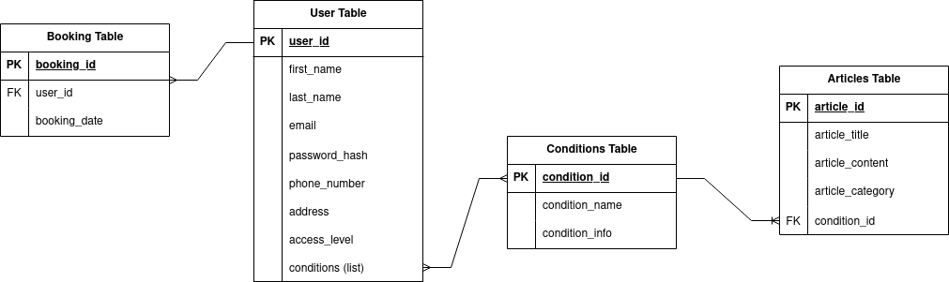

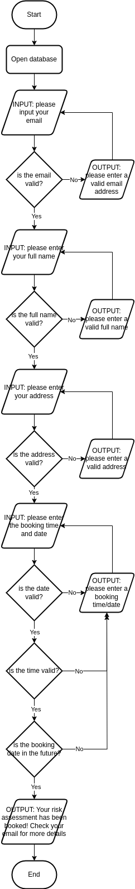
Algorithms
This should have:
- Flowcharts (include those with calculations)
  - Register form
  - Articles search algorithm
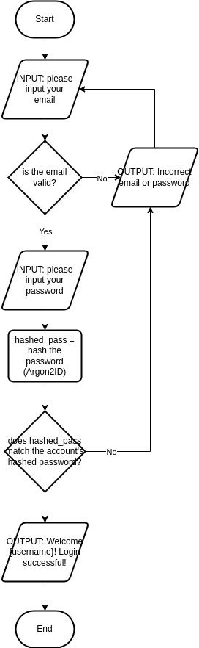
  - Edit account details
- Pseudocode (no syntax)
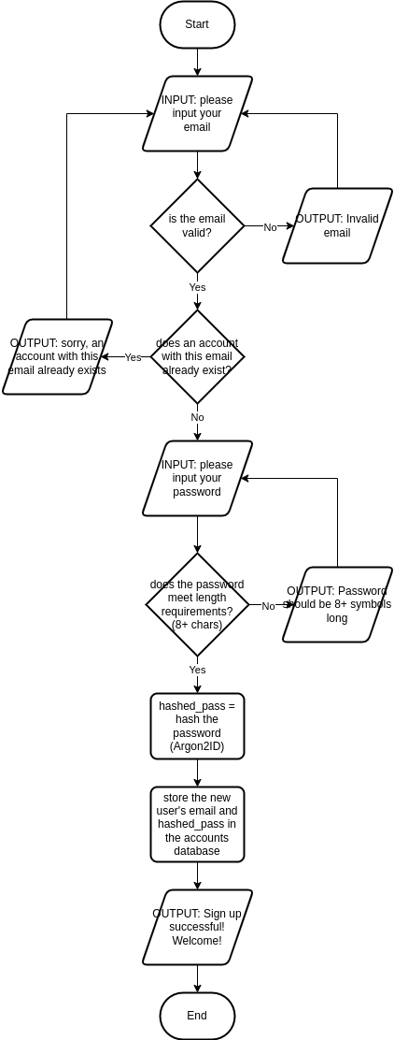

Test Strategy
This should have:
- Unit testing
- Integration testing
- Black box testing
- System testing
- Acceptance testing
- Cover different test types and specify the use of normal, erroneous, and extreme test data
Date of test | Component to be tested? | Type of test to be carried out | Prerequisites and dependencies
22/11/2025 | Navigation bar – does it load? Is placement correct? Do the links work? | Unit test
22/11/2025 | Footer – does it load? Do the links work? | Unit test
22/11/2025 | Register form – does it load? | Unit test
22/11/2025 | Register form – does it accept valid data? | Unit test
22/11/2025 | Register form – does it reject invalid data? | Unit test
22/11/2025 | Login form – does it load? | Unit test
22/11/2025 | Login form – does it accept valid data? | Unit test
22/11/2025 | Login form – does it reject invalid data? | Unit test
22/11/2025 | Home page content – does it load? | Unit test
22/11/2025 | Home page content – do links work? | Unit test
22/11/2025 | Home page full – does it load? | Integration test | Navigation bar, Footer
22/11/2025 | Home page full – is the page responsive to mobile layouts? | Unit test | Navigation bar, Footer
22/11/2025 | Article search – does it return relevant articles? | Unit test
22/11/2025 | Article search – does it accept valid data? | Unit test
22/11/2025 | Article search – does it reject invalid data? | Unit test
22/11/2025 | Articles page – does it load? | Integration test | Article search
22/11/2025 | Articles page – is the page responsive to mobile layouts? | Unit test | Article search
22/11/2025 | Booking risk assessment – does it load? | Unit test
22/11/2025 | Booking risk assessment – presence check (is all data inputted?) | Unit test
22/11/2025 | Booking risk assessment – does it accept valid data? | Unit test
22/11/2025 | Booking risk assessment – does it reject invalid data? | Unit test
22/11/2025 | Booking risk assessment - is the page responsive to mobile layouts? | Unit test
22/11/2025 | Navigation bar – does the home page link work? | Integration test | Navigation bar, Home page
22/11/2025 | Navigation bar – does the accounts page link work? | Integration test | Navigation bar, Accounts page
22/11/2025 | Navigation bar – does the articles page link work? | Integration test | Navigation bar, Articles page
22/11/2025 | Navigation bar – does the article search field work? | Integration test | Navigation bar, Article search
22/11/2025 | Navigation bar – does the about us page link work? | Integration test | Navigation bar, About us page
22/11/2025 | Navigation bar – does the weather page link work? | Integration test | Navigation bar, Weather page

